M-STAR
Marietta Strategically Targeting Areas with Resources
Tuesday, January 15, 2018 @ 9:00 a.m.

Marietta Police Department
Roll-Call Room
Attending: Chief Dan Flynn
Deputy Chief Ferrell
Deputy Chief Beam
Major Campisi
Major King
Major Marshall
Major Kish
Lieutenant Goins
Lieutenant Stephenson
Sergeant Baldwin
Sergeant Honea
Sergeant Liedke
PIO Officer McPhilamy
Elizabeth Hobbs
Jennifer Torp
Laurie Dennison

Major King began the meeting at 9:00 a.m.

Zone 1-Major King

Monthly Comparison (-16%)

 | 2017 | 2018 | Difference
Homicide | 0 | 0 | 0
Rape | 0 | 1 | 1
Robbery | 2 | 0 | -2
Aggravated Assault | 3 | 3 | 0
Burglary | 9 | 6 | -3
Larceny | 53 | 43 | -10
Vehicle Theft | 7 | 9 | 2

Year to Date (-15%)
 | 2017 | 2018 | Difference
Homicide | 3 | 1 | -2
Rape | 6 | 13 | 6
Robbery | 43 | 27 | -16
Aggravated Assault | 28 | 31 | 3
Burglary | 102 | 77 | -25
Larceny | 673 | 555 | -118
Vehicle Theft | 66 | 78 | 12

Action Being Taken
- Multifaceted approach to solve and deter crime

Zone 1 Updates
- Drive Shack tanked
- School House Brewery
- Old Marietta Salvage Yard (Zone 2)
- Flock up and running

Complaints and Action Forms
- No complaints

Meetings

- CID Meeting January 14th

Zone 2- Major Campisi

Monthly Comparison

 | 2017 | 2018 | Difference
Homicide | 0 | 0 | 0
Rape | 0 | 0 | 0
Robbery | 3 | 3 | 0
Aggravated Assault | 2 | 3 | +1 (50%)
Burglary | 12 | 3 | -9 (75%)
Larceny | 25 | 16 | -9 (75%)
Vehicle Theft | 4 | 4 | 0

Dec. 2017 | Dec. 2018 | Number | Difference
46 | 29 | -17 | -36%

YTD Comparison January-December

 |  | Jan – Dec 2017 | Jan – Dec 2018 | Difference
 | Homicide | 0 | 2 | NC
 | Rape | 2 | 5 | +3 (150%)
 | Robbery | 24 | 14 | -10 (-42%)
 | Aggravated Assault | 15 | 17 | +2 (13%)
 | Burglary | 78 | 61 | -17 (-22)
 | Larceny | 365 | 323 | -42 (12%)
Vehicle Theft | 53 | 38 | -15 (-28%)

Jan-Dec 2017 | Jan-Dec 2018 | Number | Difference
537 | 460 | -77 | -14%

Strategic Response
- IZP / Field Interviews in the areas of:
- 1051 Canton Rd (Home Stay Inn)
- Bells Ferry Rd @ Williams Dr.
- Zone Patrols – Storage Unit Facilities
- Cell phones / Stores

Complaints since Last Meeting

- Previous Complaints Follow – Up
- Illegal Parking on Cloverdale Dr.
- Illegal Dumping – 640 N. Greenbriar Pkwy

Meetings

- January 17 @ 1730 hours
- Community Meeting at 1955 Bells Ferry Road
- Laurel Hill Preserve Apartment Community

Zone 3- Major Kish

Monthly Comparison (-12%)

 | 2017 | 2018 | Difference
Homicide | 0 | 0 | 0
Rape | 0 | 0 | 0
Robbery | 1 | 0 | -1
Aggravated Assault | 1 | 4 | +3
Burglary | 2 | 4 | +2
Larceny | 25 | 20 | -5
Vehicle Theft | 3 | 1 | -2

Year-to-Date Comparison (-1%)

 | 2017 | 2018 | Difference
Homicide | 0 | 0 | 0
Rape | 5 | 3 | -2
Robbery | 10 | 8 | -2
Aggravated Assault | 14 | 21 | +7
Burglary | 54 | 40 | -14
Larceny | 336 | 339 | +3
Vehicle Theft | 26 | 28 | +2

Complaints and Response
- CCT Transfer Station – safety concerns
- Roswell St @ Coggins – cyber request for development
- Cole @ Fort – 54 at bus stop
- White Columns Inn - 38
- Elizabeth Porter Park – vandalism
- Deer Creek Gun Shop - 42
Ongoing Strategies

- Shift and unit patrols through the S. Marietta Pkwy corridor and in the neighborhoods
- Increased patrols at CCT transfer station
- Update CT agreements with businesses along S. Marietta Pkwy
- Traffic Enforcement in complaint areas
- Foot Patrols in Wal-Mart
- Communication with CIU regarding 38 complaints

Zone 4- Major Marshall

Monthly Comparison

Overall Part 1 Crime for the Month (-41%)

 | 2017 | 2018 | Difference
Homicide | 0 | 0 | 0
Rape | 1 | 0 | -1
Robbery | 1 | 3 | 2
Aggravated Assault | 3 | 0 | -3
Burglary | 3 | 5 | 2
Larceny | 23 | 25 | 2
Vehicle Theft | 2 | 1 | -1

December 2017 | December 2018 | Number | Difference
33 | 34 | 1 | 3%

Yearly Comparison

Overall Part 1 Crime for YTD: (-14%)
 | Jan-Dec 2017 | Jan – Dec 2018 | Difference
Homicide | 3 | 1 | -2
Rape | 3 | 7 | 4
Robbery | 23 | 22 | -1
Aggravated Assault | 24 | 23 | -1
Burglary | 91 | 39 | -52
Larceny | 287 | 284 | -5
Vehicle Theft | 21 | 13 | -8

END OF YEAR Part 1 Crime Totals

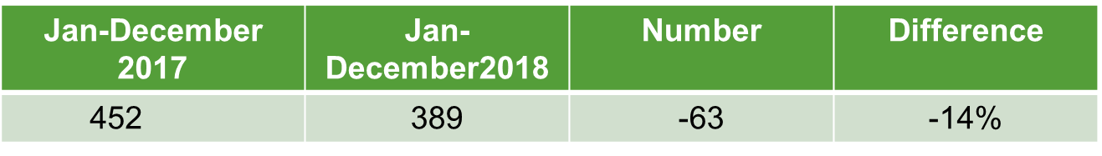

Strategic Response

- Use of Public Safety Ambassadors for continued public awareness campaigns in neighborhoods

Complaints Since Last Meeting

- MMS Crosswalks
- Sentinel Ridge Water issue/Code Enforcement

Meetings

- None at this time.

Detectives – Lt. Rutland

Monthly Statistics – December 2018

- Cases Assigned 52/62
- Arrests 20
- Search Warrants 10
- Call-Outs 13
- AFIS-Searches/Hits 25/11
- Marijuana Tests 58
- Citizen Stat Requests 5
- Internal Stat Requests 38
- Phone/Name Searches 117

Annual Activities

- Cases Assigned/Cleared/Active 1238/788/250
- Arrests 200
- Search Warrants 137
- Call-Outs 216
- AFIS- Searches/Hits 351/92
- Marijuana Tests 540
- Citizen Stat Requests 121
- Internal Stat Requests 559
- Phone/Name Searches 2077

Detectives
- Whitlock Chevron cigarette truck heist
- Franklin Gateway drug rip/shooting
- Money Making Gang round up @ MHS
- Theft by receiving – Illinois organized crime ring investigation assist
- Ed Voyles MVTs
- Shop with a Cop
Cyber
- Drug Trend Report
- Aggravated Assault Report
- Ed Voyles investigation
- Multi-agency gun shop burglary analysis
- ICAC statistical analysis
- Media Sonar demo
- Formulytics meetings & admin training

FBI-Safe Streets

- Reynolds – MHS/Make Money Gang round up
- Reynolds – Bounty Hunter Bloods round up
- Selleck – assignment to AMMO (swearing-in delayed)
- Selleck – Loomis Armed Truck Robbery
- Selleck – Deer Creek Gun Shop case
- Other misc. TF work outside Marietta

Upcoming Events

- Super Bowl LII MATCH detail Feb 1
- Bollinger in Cellebrite
- Parker & Ellenson cont. training
- Selleck gets sworn in?

MCS Narcotics – Lieutenant Goins

MCS Cases in the City of Marietta

- The Unit opened 35 new cases in the month of December 2018, 07 cases were in the City of Marietta.
- The Unit made 8 arrests within the City of Marietta.

Zone 1
- The Unit worked 3 cases and made 3 arrests in Zone 1 during the month of December 2018.
- The Unit seized 8.4 grams of Marijuana.
- Total seized drug value $84.00.
- The Unit seized $982.00.

Zone 2
- The Unit worked 01 cases and made 02 arrests in Zone 2 during the month of December 2018.
- The Unit seized 64.00 grams of Marijuana.
- Total seized drug value $640.00.

Zone 3
- The Unit worked no case and made no arrests in Zone 3 during the month of December 2018.

Zone 4
- The Unit worked 3 case and made 3 arrests in Zone 4 during the month of December 2018.
- The Unit seized 21.7 grams of Marijuana.
- Total drug value $ 385.00.

MCS UNIT TOTALS – December 2018

- 11 DRUG BUYS
- 09 SEARCH WARRANTS
- 27 TOTAL ARRESTS
- 24 OTHER AGENCY ASSIST
- SEIZED DRUG VALUE - $249,675.00
- SEIZED MONEY- $11,402.00
- SEIZED WEAPONS - 5
- SEIZED VEHICLES – 2
- TOTAL COMPLAINTS 32 (ALL TIP LINES) CLEARED FOR DECEMBER 2018 WAS 4

STEP – Sgt Honea

Details/Events/Training
- MATEN Meeting @ Smyrna PD
- Shop with a Cop
- Holiday Around the World
- PAL Christmas Event
- Holiday Saturation Patrols
- New Years Eve Enforcement
- Rakestraw out on Baby Leave

STEP Crash Investigations

- 12/11/18 Cobb Parkway @ Canton Connector – Serious Injury
- 12/12/18 I-75 s/b @ South Marietta Parkway – Fatality
- 12/14/18 Whitlock Avenue @ Kirkpatrick – Serious Injury (Ped)
- 12/15/18 I-75 s/b @ South Marietta Parkway – Fatality
- 12/30/18 Powder Springs Rd @ Chestnut Hill Rd – Fatality (Ped)
- Case 0118020895 Fatality (Vehicle)
- I-75 s/b @ South Marietta Parkway

Driver of a 2008 Infiniti G37 lost control striking the median wall and then hitting a 2010 Chevy Silverado. The Silverado was then struck by two tractor trailers, killing one of the back-seat passengers. The crash scene involved all lanes of the interstate being closed for several hours.
The Infiniti Driver has been charged with Homicide by Vehicle 2nd Degree, Failure to Maintain Lane and Window Tint Violation.

- Case 0118021135 Fatality (Vehicle)
- I-75 s/b @ South Marietta Parkway
Driver of 2006 Mazda 6 lost control of her vehicle leaving the right side of the roadway. In an attempt to regain control, the driver over corrected and began a counter clockwise rotation across the interstate. The Mazda was struck by a 2010 Chevy Suburban that was pulling a boat. The impact killed the driver of the Mazda and seriously injured the passenger. No one in the suburban was injured. The decedent’s BAC was three times the legal limit.
No charges have been filed in the case.

- Case 0118021823 Fatality (Pedestrian)
- Powder Springs Road s/of Chestnut Hill Road
A male pedestrian was attempting to cross Powder Springs Road south of the intersection where a crosswalk was provided. The pedestrian darted out into the path of a 2006 Infiniti G35 and was struck. He was transported to WellStar Kennestone Medical Center where he passed the following day.
No charges have been filed in the case.

Holiday Enforcement Details

December 6th:
Zone 2 and Zone 3 Concentrated Enforcement
Citations Issued - 57
No Arrest
December 7th:
Zone 4 Traffic Checkpoint ( Bellemeade Drive @ Longwood Drive)
Citations Issued: 19
Arrests: 4 (3 license issues and 1 for VGCSA Marijuana)

December 13^{th:}
Zone 2 Traffic Checkpoint (Williams Drive)
Citations Issued: 5
No Arrest Made
December 18th – 21st:
Night / DUI Enforcement
Citations Issued: 80
Arrests Made: 4 (3 for DUI and 1 for Wanted Person)

STEP Monthly Totals

- Fatality Crashes 003
- Serious Injury Crashes 002
- Total Traffic Stops 181
- Total Citations 224
- Total Arrest 015
- Warnings Issued 023
- Crash Cases Active 004
- Assist Calls for Service 021
- Hit and Run Cases Assigned 006

Accident Data

- Fatality Crashes 003
- Serious Injury Crashes 002
- Total Traffic Stops 181
- Total Citations 224
- Total Arrest 015
- Warnings Issued 023
- Crash Cases Active 004
- Assist Calls for Service 021
- Hit and Run Cases Assigned 006

Top Five Accident Locations

- S Marietta Pkwy @ S Fairground St
  - 3 Following too Close
  - 2 Changed Lanes Improperly
  - 1 Failure to Yield
  - 1 Other
  - 1 Improper Turn
- Cobb Pkwy S @ Windy Hill Rd
  - 4 Following Too Close
  - 1 Improper Turn
  - 1 Other
- Powder Springs St @ Sandtown Rd
  - 2 Following too Close
  - 1 Changed Lanes Improperly
  - 1 Other
  - 1 Failure to Yield
  - 1 No Contributing Factors
- Cobb Pkwy N @ N Marietta Pkwy
  - 2 Following Too Close
  - 1 Failure to Yield
  - 1 Changed Lanes Improperly
  - 1 Inattentive of Other Distraction
- Cobb Pkwy S @ S Marietta Pkwy
  - 2 Following Too Close
  - 1 Changed Lanes Improperly
  - 1 Improper Backing
  - 1 No Contributing Factors

CRU- LT Baldwin

Monthly Events
- American Heart Assoc 5K
- Veterans Day Parade
- Cherokee Heights Art Festival
- Active Shooter House of Worship Seminar in Atlanta
- Judge Hines Funeral Detail
- MCAA Reunification Exercise
- Gobble Jog
- Christmas Tree Lighting Festival on Square
- 6 Teacher CRASE presentations at MCS Elementary Schools
- CRU Holiday Plan
- Red Kettle Kick Off for Salvation Army

SRO/Parking Report
- 4 arrests at MHS for fighting
- Initial Investigation began for Gang activity within MHS
- SWAT Training

Parking Citations Written:

Month | Totals
August | 357
September | 335
October | 231

EXPLORERS

- Revamp the POST
- Officer Arrington selected as new POST Advisor
- HEAVY Recruitment campaign currently underway
- Re-newed Charter

Graffiti Prevention Program
No reported incidents
- Creation of new, CRU Homeless Initiative
  - Increase in enforcement activities
  - Impact of new MUST Complex and Veterans Hospital
  - Research into new and existing programs
  - Better use of crime and calls for service data
  - Collaboration between Cobb PD/Rangers
  - New maps for tracking campsites and crime
  - Involvement of Volunteers
  - Streamlining and verification of CT Warnings

Crime Interdiction Unit – Sergeant Liedke

December 2018 Totals

- Total Arrests -------------------------- 12
- Felony Arrests ----------------------- 06
- Misdemeanors ---------------------- 06
- Narcotics Arrests ------------------- 07
- Non-Narcotic Related Arrests --- 05
- Search Warrants -------------------- 00
- Details --------------------------------- 02
- Controlled Buys --------------------- 00
- Complaints Cleared ---------------- 00

Felony Arrests
- CRACK
- COCAINE
- MARIJUANA
- OXY
- MDMA
- SALES / MARIJUANA / COCAINE

Misdemeanor Arrests
- Marijuana
- Traffic charges (street racing / License)
- Wanted people located

Complaints Cleared
- Continued work on Roosevelt Circle
- No new tips or complaints

Zone 1
- 03 arrests
- 00 Misdemeanors
- 03 Felonies
- 02 Drug related arrests
- 01 Non drug related arrest
- 2 ounces of Weed, Oxy, MDMA (Fast Trip B/F)

Zone 2
- 03 Arrests
- 02 Misdemeanors
- 01 Felony
- 01 Drug related arrest
- 02 Non drug related arrests
- Checkpoint in Zone 2
- Street Racing

Zone 3
  - 04 Arrests
  - 03 Misdemeanors
  - 01 Felony
  - 03 Drug related arrests
  - 01 Non drug related arrest
  - McIntosh case…….20+ hours of video
  - Sales case from the porch…..

Zone 4
- 02 Arrests
- 02 Misdemeanors
- 00 Felonies
- 01 Drug related arrest
- 01 Non drug related arrest
- Felony Marijuana

Canine Unit
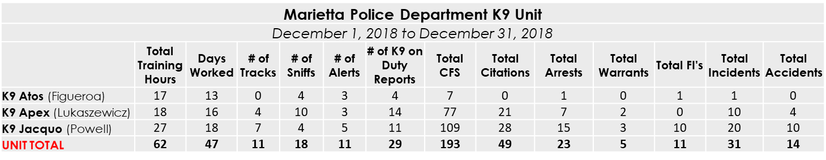
Additional Information : ATOS
- ED VOYLES DODGE DETAIL DEC. 17 TO 21
- 12/6 CONDUCTED SNIFF FOR HINES. CRACK PIPE ARREST
- 12/6 CONDUCTED SNIFF FOR WASHINGTON. 20 GRAMS OF METH AND STOLEN GUN LOCATED
- 12/11 CONDUCTED SNIFF FOR MYSELF AND LOCATED .5 GRAM OF POWDER COCAINE

Additional Information : APEX
- 12/8 - Signal3 with an open door and numerous interior activations. Since the business was closed, Apex was deployed in the large warehouse after verbal commands. He was able to search for suspects with numerous boxes and machines inside (which would easily conceal a suspect from officers) and located no one inside. a secondary clear with officers yielded the same result.
- 12/15 - Sgt Buehler requested K9 in reference to a 42 of a car dealership. He first requested us to help check a rear parking lot that the suspects may have been hiding in. After clearing the lot, I deployed Apex for an article search. He located 3 stolen key fobs in the grassy area behind the collision center.
- 12/15 - Possession with Intent Marijuana and Possession with Intent Crack Cocaine on McIntosh Ave. Watched a hand to hand and a investigation lead to several drug charges.
- 12/22- K9 Apex was requested for the perimeter of a barricaded Agg Assault suspect by Cobb County. Suspect eventually surrendered without incident.
We were later requested for a related article search for the firearm used in the Agg Assault.
- 12/28 - Assisted with a SW that lead to Possession with Intent Marijuana, Possession of a Firearm by Convicted Felon, Possession of a Firearm during Comm of Felony, and Cruelty to Children Charges. Two arrests.

Additional Information : JACQUO
- CITY CAR: 12/2, 12/3, 12/4, 12/8, 12/9, 12/21, 12/27
- ZONE CAR: 12/14, 12/15, 12/16, 12/20, 12/22, 12/23, 12/28, 12/29
- 12/06: Called in by Sgt. Culpepper for K9 Track of Mentally Ill suspect. Located suspect in creek, naked. #0118020534
- 12/08: Came in at 1100 hours to assist Day Shift due to manpower shortage. (8232)
- 12/14: Shop with a Cop
- 12/15: Cobb Pct. 5(#18118441) K9 request for track. for car thief out of Paulding S.O.(#20181253691) K9 Jacquo tracked, located gun, keys, cell phone and suspect! #0118021136
- 12/22: K9 track after male fled on scene while being arrested. K9 Jacquo located in thick vegetation. #0118021534
- 12/23: Sniff with 15 grams marijuana / THC vape pen located for CCPD 2 arrest.jo
- 12/24: While conducting an article search for MW case, K9 Jacquo located the victim of the case hiding behind a shed in the backyard of the residence.

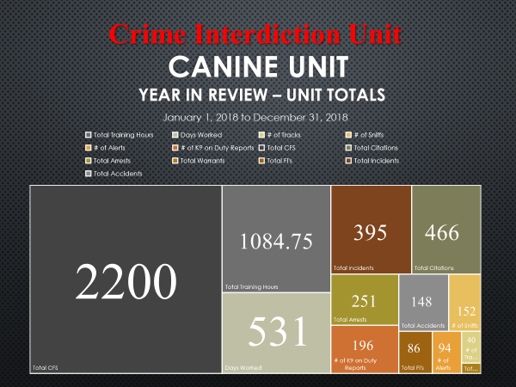

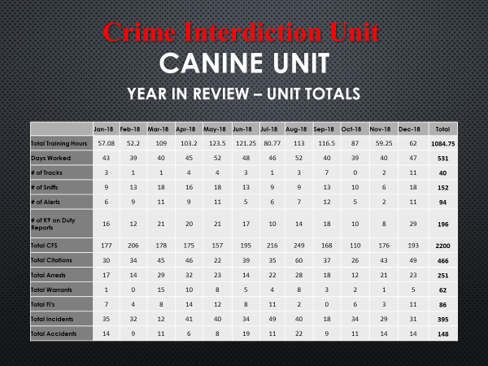

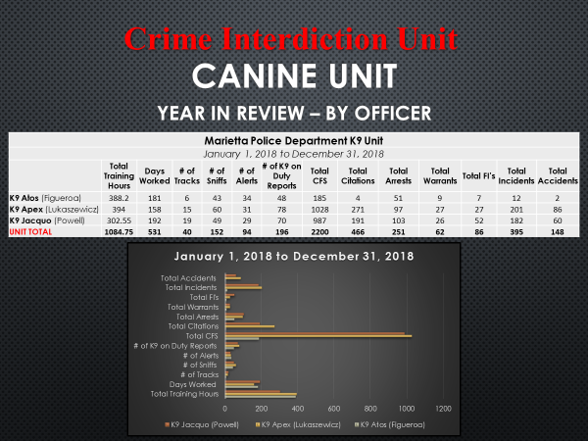

Shift Assistance & Details
- Safety Checkpoint with STEP
- Ed Voyles C9 Detail for 1 week
CIU Complaints

Zone 1
- N/A

Zone 2
- N/A

Zone 3
- N/A

Zone 4
- N/A

Side Note
CIU has made:
    - 204 arrests (Avg. 17 per month)
    - 154 days
    - 24 search warrants
    - 00 complaints
    - 02 MPD 100’s

End of Discussion
Nothing Further
End of Meeting 10:07 a.m.

