M-STAR
Marietta Strategically Targeting Areas with Resources
Tuesday, July 16, 2019 @ 9:00 a.m.

Marietta Police Department
Roll-Call Room
Attending: Chief Dan Flynn
Deputy Chief Ferrell
Deputy Chief Beam
Major Campisi
Major King
Major Kish
Major Marshall
Major Twaddell
Lieutenant Bonito
Lieutenant Rutland
Sergeant Baldwin
Sergeant Foster
Sergeant Honea
Sergeant Liedke
PIO Officer McPhilamy
Officer Paul Hill
Cyber Analyst Jennifer Torp
Admin Julie Smith

Major Campisi began the meeting at 9:00 a.m.

Major Campisi opened up the meeting by presenting Officer Matthew Salyers with the Medal of Meritorious Service award for his extraordinary lifesaving event.
Major Kish presented Sergeant Foster with the Distinguished Service Award for his extraordinary work with MATCH and taking on the lead detective role on homicide cases when needed.
Major Campisi presented Officer Paul Hill with the Officer of the 2nd quarter award and Cyber Analyst Jennifer Torp with the Civilian of the 2nd quarter award.

Zone 1-Major King

Monthly Comparison (+12%)

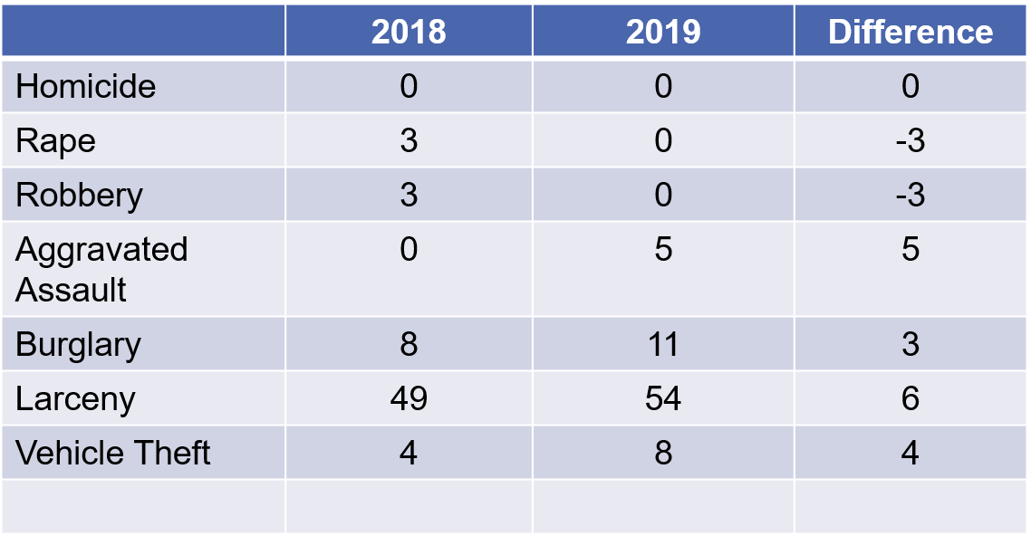

Year to Date (-3%)

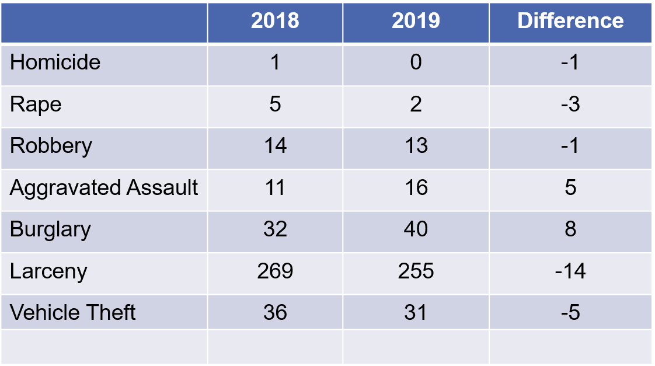

Action Being Taken
- Burglary Suppression

Zone 1 Updates
- None at this time

Complaints and Action Forms
- No complaints

Chief made comments in reference to new construction starting on Franklin Road

Meetings

- None at this time however the Back to School Bash will be Saturday July 20th

Zone 2- Major Campisi

Monthly Comparison

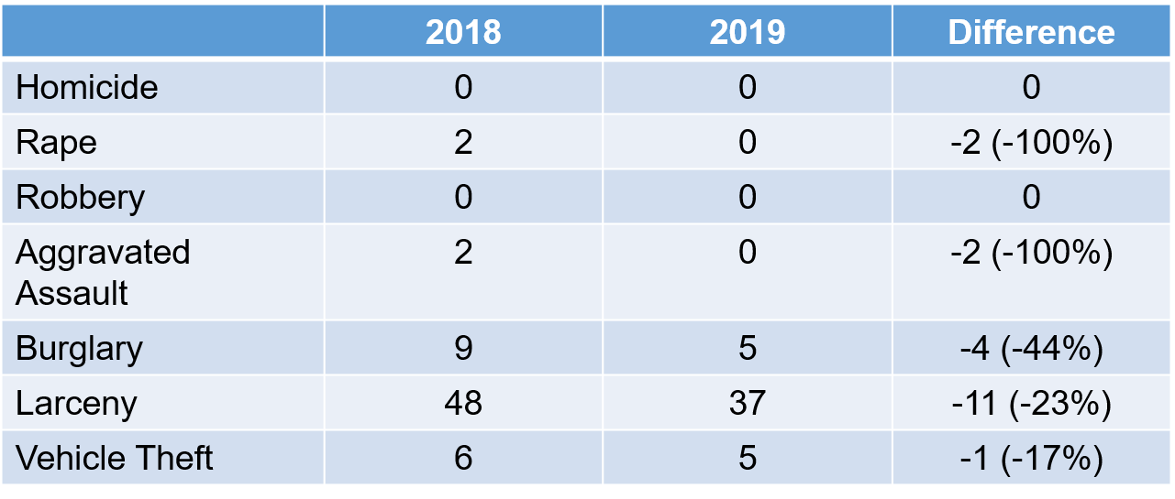

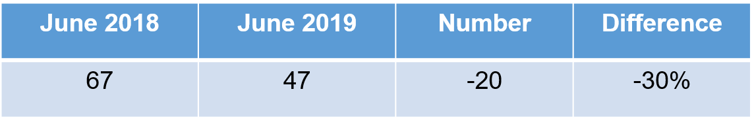

YTD Comparison January-June

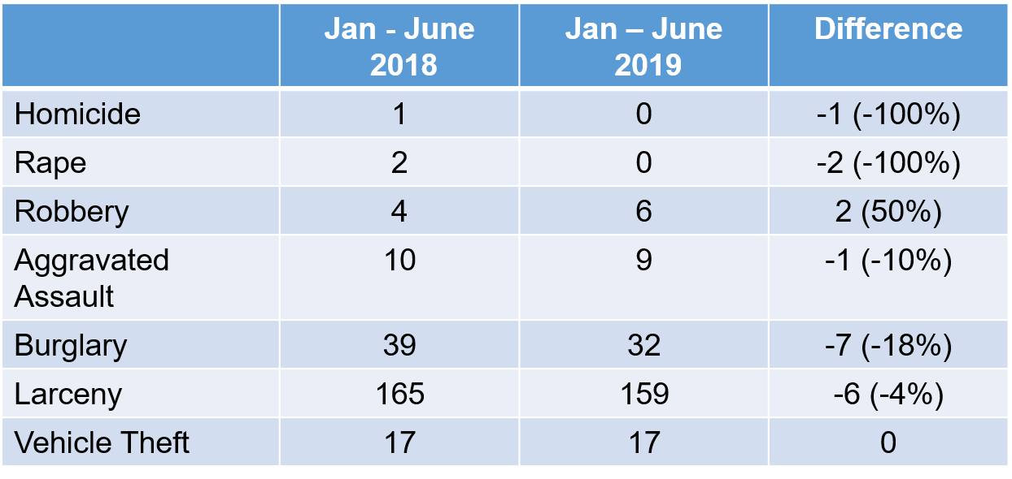

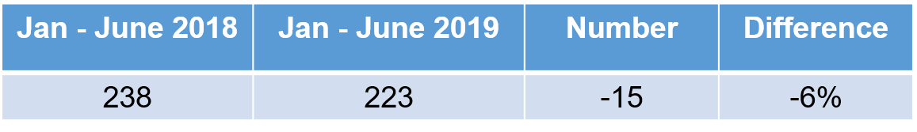
Strategic Response
- Directed and IZPs at Zone 2 Family Entertainment Venues (SMG, Andretti’s, & White Water)
- Directed and IZPs at “Point in Time” Targets
- Ghost Cars along Roswell Road

Complaints Since Last Meeting

- Drug Complaint - 425 Williams Dr. #921
- Traffic Complaints – Beech St.

Meetings

- August 10th – Eagle Ridge S/D HOA (Soaring Drive) @ the Sewell Mill Library

Zone 3- Major Kish

Monthly Comparison (-19%)

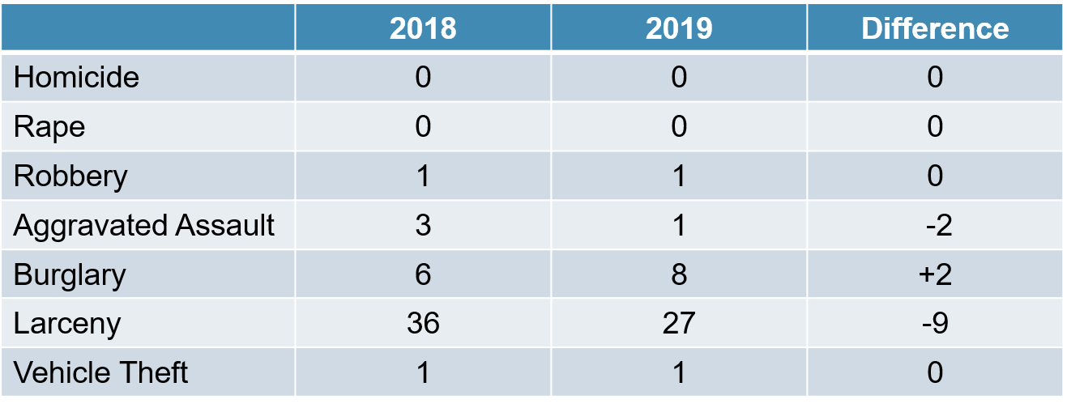

Year-to-Date Comparison (-6%)

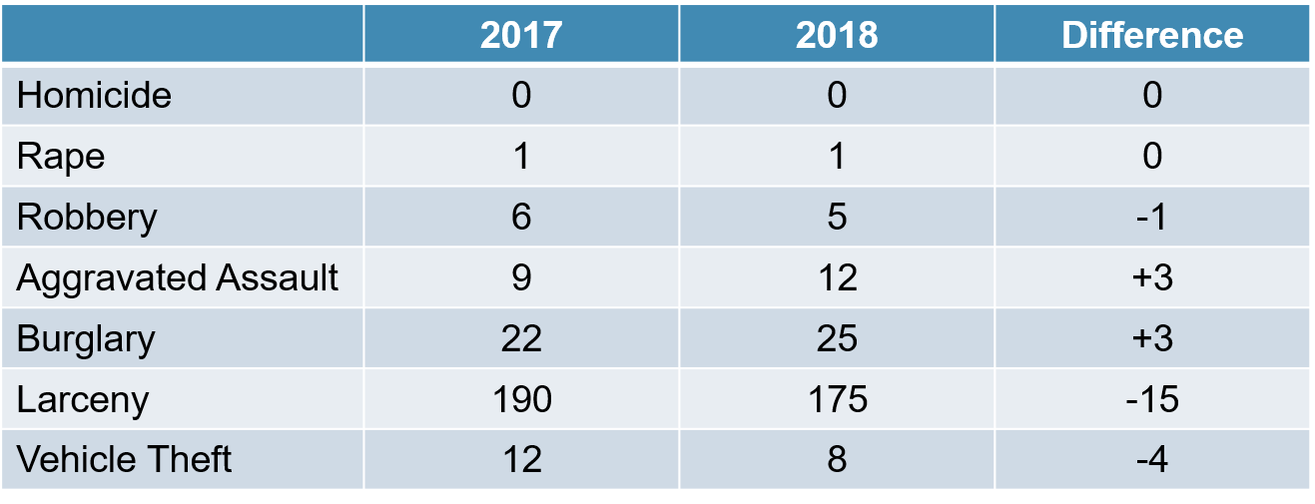

Complaints & Response
- 223 Avery St - ZP
- Glover Park – Non-profits/Jack Harshaw
- Winters St – Markings for parking
- 318 Allgood Rd – Condemned property
- Cherokee St - Speeding
- Cole St - 37
- Delk St - 37
- 843 Toliver St - 37
- Crosswalks on square - traffic
- 322 Lyman Dr – ZP

Ongoing Strategies
- Shift and unit patrols through the S. Marietta Pkwy corridor and in the neighborhoods
- Increased patrols at CCT transfer station
- Update CT agreements with businesses along S. Marietta Pkwy
- Traffic Enforcement in complaint areas
- Foot Patrols in Wal-Mart, continued usage of Ghost Car, need increased effort based on last month’s increase
- Communication with CIU regarding 38 complaints

Zone 4- Major Marshall

Monthly Comparison (+1%)
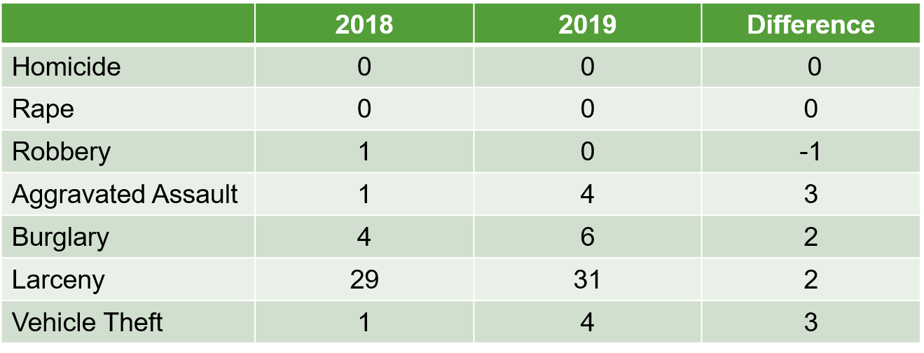

YTD Comparison January-June

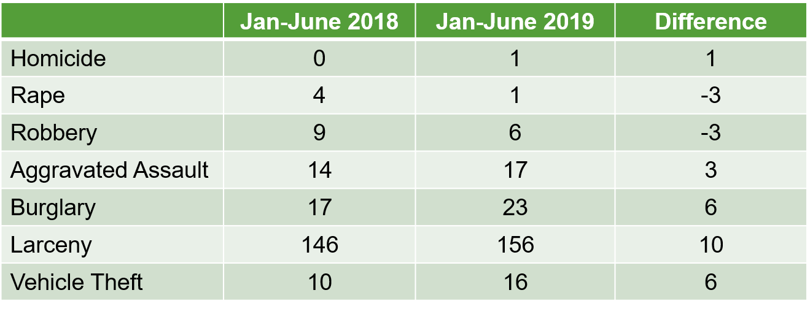

Part 1 Crime Totals

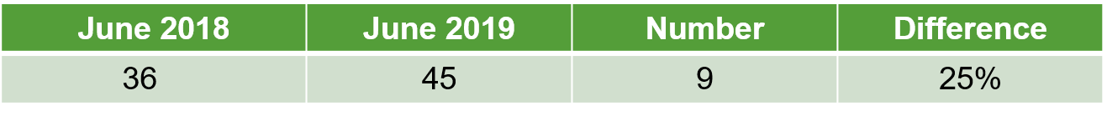
YTD Part 1 Crime Totals

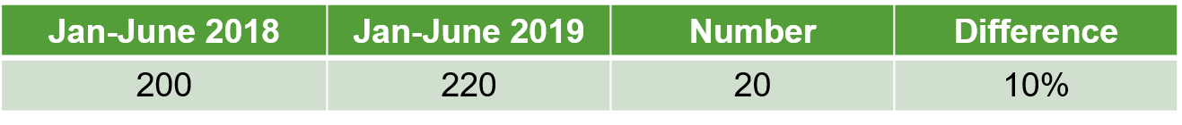

Strategic Response
- Public awareness campaigns in neighborhoods
- Use of ghost cars
- STEP Sign Trailers

Complaints Since Last Meeting
- Lewis Park (kids/picnics in Dog Park)
- Tower Ridge Condo- (parking again)
Meetings
- Burnt Hickory Crossing- TBD

Detectives – Lt. Rutland

Monthly Statistics – October 2018

- Cases Assigned 105/86
- Arrests 23
- Search Warrants 14
- Call-Outs 14
- AFIS-Searches/Hits 46/4
- Marijuana Tests 15
- Citizen Stat Requests 5
- Internal Stat Requests 39
- Investigative Searches 109

Detectives
- Right Way Dealer – 6 MVTs, multiple keys – 4 cars recovered in Forest Park + suspects
- Wal-Mart kidnapping attempt
- 6 shooting investigations = 3 other agencies and 3 MPD
Cyber
- IT/City Manager presentation meeting
- FBICTG Meeting
- GA Street Gang Terrorism & Prevention Act Training
- Juneteenth Cyber vetting
- 3 intern Cyber vetting
- Investigative assists

TFOs

- Reynolds – Joint FBI Operation in Metro ATLA
- Miller – 7 kilo of meth, $4mil, $811K & 1lb of meth
- Burgess – Boko Haram investigation, child porn trafficker arrest

Upcoming Events

- NIBRS transition
- NIBN project w/ CCPD
- National Gang Investigator’s Conference
- FBI Course - Highway Serial Killings & Behavior Analysis

STEP – Sgt Honea

Details/Events/Training
- MATEN Meeting
- CRT Training (8 hours)
- Juneteenth Detail on Square
- Military Convoy Escort from Dobbins
- Citizens Academy - Rakestraw
- St. Onge – Crash Reconstruction Level 5
- Henry – Crash Reconstruction Level 5
- St. Onge – Vacation (week)
- Multi Agency Hands Free Enforcement Detail

STEP Crash Investigations

- Case Number 0119010477
- June 2, 2019
- Whitlock Avenue at MHS

An unrestrained male driver received serious head trauma after rear ending another vehicle with no pre-impact braking. The driver was originally unresponsive but will survive.

Hands Free Enforcement Detail

- 2 ½ Hour Detail
- 170 Citations Issued
- 80 for Hands Free
- 3 Arrests
- Enforcement Plan adopted by Tennessee Highway Patrol – Nashville Division

STEP Monthly Activity

- Fatality Crashes 000
- Serious Injury Crashes 001
- Total Traffic Stops 247
- Total Citations 327
- Total Arrest 012
- Warnings Issued 030
- Active Crash Investigations 002
- Investigative Crash Hours 012
- Hit and Run Cases Assigned 014
- Assist Shift with Calls 021

Parking Enforcement

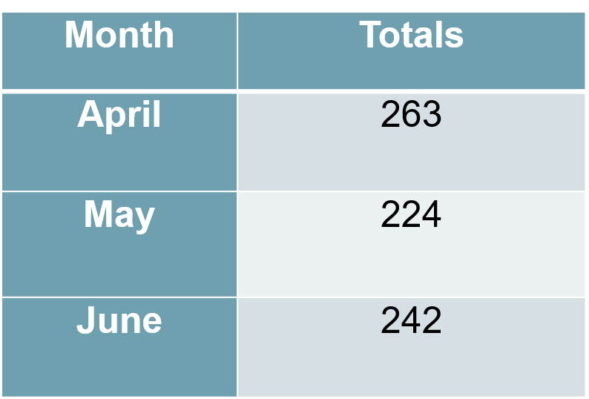

Crash Data

- Total Accidents 435 DC Ferrell asked for Sgt. Honea to check stats
- MPD Accidents Involving DUI 001 from 2018 to see if they are significantly lower
- STEP Accidents Involving DUI 000
- Fatality Accidents 000
- Serious Injury Accidents 000

Top Five Crash Locations

- Cobb Pkwy N @ Canton Rd Conn
  - 4 Following Too Close
  - 2 Failure to Yield
  - 1 Misjudged Clearance
  - 1 Improper Turn
- S Marietta Pkwy @ Lower Roswell Rd
  - 3 Following Too Close
  - 3 Changed Lanes Improperly
  - 1 No Contributing Factors
- S Marietta Pkwy @ Whitlock Ave
  - 4 Following Too Close
  - 2 Changed Lanes Improperly
  - 1 Failure to Yield
- S Marietta Pkwy @ S Fairground St
  - 3 Following Too Close
  - 1 No Contributing Factors
  - 1 Failure to Yield
  - 1 Improper Turn
- Cobb Pkwy N @ Allgood Rd
  - 3 Following Too Close
  - 1 Too Fast for Conditions
  - 1 Other

CRU- LT Baldwin

Monthly Events
- RadKIDS Summer Camp
- Juneteenth
- Marietta High School Police Academy
- Varsity Lunch @ MPD
- Citizens Academy
- Mt. Zion Preschool Talk
- NASRO Conference
- CRU Officers attended various training classes

SRO
- Physical Security upgrades to MHS and MMS
- Addition of 2 new Elementary SRO’s

Volunteers

- Name Candidating
- Volunteer Patrol
- Assist with events on Square
- Volunteer Hours: 160

EXPLORERS

- Working on fund raising events
- Continued weekly training
- Explorer Hours: 159+ hours

Graffiti Incidents
No reported incidents
Criminal Trespass
- Continuing to work with community, businesses and HOA groups in affected areas

Crime Interdiction Unit – Sergeant Liedke

June 2019 Totals

- Total Arrests -------------------------- 15
- Felony Arrests ----------------------- 09
- Misdemeanors ---------------------- 06
- Narcotics Arrests ------------------- 15
- Non-Narcotic Related Arrests --- 00
- Search Warrants -------------------- 07
- Details --------------------------------- 06
- Controlled Buys --------------------- 00
- Complaints Cleared ---------------- 06

Felony Arrests
- Crack
- Cocaine
- Meth
- Marijuana
- Pills
- Heroin
- Felon with a firearm

Misdemeanor Arrests
- Marijuana
- Wanted people located
- Fleeing and eluding (STEP assist)
- Disorderly conduct

Complaints Cleared
- 1113 Powers Ferry Place
- 533 Campbell Hill Street
- 318 Roosevelt Circle
- 425 Williams Drive Apt. 921
- 1244 Dot Street
- 314 Chestnut Hill Dr

Zone 1
- 05 arrests
- 03 Misdemeanors
- 02 Felonies
- 03 Drug related arrests
- 02 Non drug related arrests
- SW @ 1113 P. Ferry Pl. 2lb weed 2k in cash

Zone 2
- 05 Arrests
- 01 Misdemeanor
- 04 Felonies
- 05 Drug related arrests
- 00 Non drug related arrests
- Dot Street case
- Williams drive C18 (Van Ness)
- SW @ 425 Williams Dr. 2LB. WEED

THE SEARCH WARRANT YIELDED
- 1,566 grams of marijuana (3.4 pounds)
- 104 grams of meth
- 125 grams of powder cocaine
- 87 grams of crack cocaine
- 30.5 grams of heroin
- 96 MDMA pills
- 2.5 grams of powder MDMA
- 158 Xanax pills
- 2 Tramadol pills
- 3 firearms
- Scales
- Baggies
- Packaging material
- Pill press
- $1,600 in fake one hundred-dollar bills

The traffic stop Chris was involved in yielded:
- 11.4 grams of meth
- 3.4 grams of crack
- 13.8 grams of marijuana
- $2,076.00 in cash

Zone 3
- 04 Arrests
- 02 Misdemeanors
- 02 Felonies
- 04 Drug related arrests
- 00 Non drug related arrests
- SW @ 318 Roosevelt Circle

Zone 4
- 01 Arrest
- 00 Misdemeanors
- 01 Felony
- 01 Drug related arrest
- 00 Non drug related arrest
- 533 Campbell Hill 10-99 38
- ICE Tramadol Case (still receiving pills)

Canine Unit

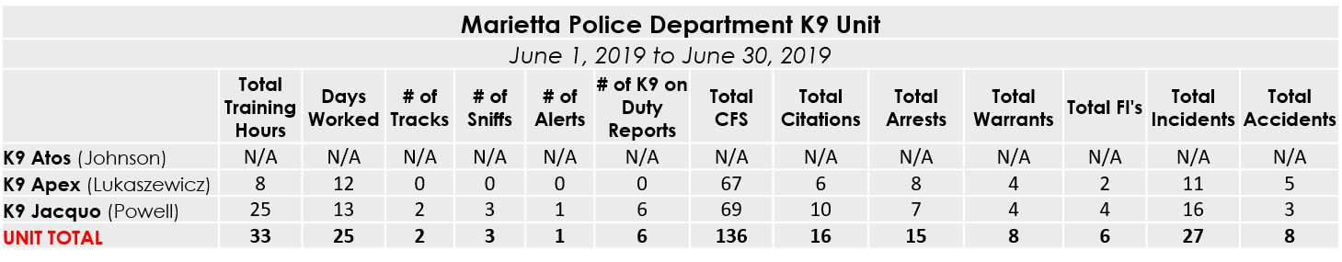

Additional Information: ATOS
- Successful transfer from Sgt. Figueroa to Officer Johnson

Additional Information: APEX
- K9 Apex Still Out of Service Due to Injury
- 6/5 - Foot patrol of Motel 6 led to the contact of 2 Ghostface gang members, a 10-80, search warrant, and two arrests for VGCSA Possession of Methamphetamine.
- 6/6 - Located a gram of cocaine on a suspect during a consent search. Subject was charged with VGCSA Possession of Cocaine and Possession of Firearm during VGCSA.
- 6/6 - During a consent search, we located Marijuana and Ecstasy. The suspect had multiple warrants and a Fugitive from Justice warrant was also taken.

Additional Information: JACQUO
- TRAINING: 06/05 (K9/SWAT), 06/19 (K9), 06/26 (K9)
- Assisted CIU/FBI/Bartow DTF with case (06/03)
- Sniff for Foster on C18. Alert with 1 gram of Meth located. 1 arrest. (06/05)
- Assisted CIU/FBI/Bartow DTF with case (06/05)
- Assisted CIU/FBI/Bartow DTF with case before work (06/08)
- On vacation 06/10-06/16
- K9 Demo/Class for High School academy 06/18
- C18 while working with CIU. Led to one arrest for marijuana possession. (06/19)
- Assisted with CIU round up / SW at 318 Roosevelt (06/20) - 3 arrests!
- 06/24: Handled detail for ASSIST team for Lt. Goins
- Assisted with SWAT search warrant for K9 support at 707 Franklin (06/25)
- Assisted with locating and taking into custody the driver that 10-80'd from Sgt. Honea two nights in a row. (06/28)
- 06/28: Assisted CIU with takedown of T3/FBI/Bartow DTF Case on Dot St. 2 Arrests!
.

Shift Assistance & Details
- Juneteenth on the Square
- SW for DA’s office on cell phone (44 case)
- Trained rookies (x2)
- STEP (bullied)
- CPA
- Z2 Town Hall

CIU Complaints

Zone 1
- Barber shop on 41
- 720 Franklin #8F

Zone 2
- 1955 Bells Ferry x4
- 1111 Beech Street
- 1051 Canton #328

Zone 3
- SiSi
- Fort & Rigby

Zone 4
- Kimberly (Camera)
- 1629 St. John Ave

Side Note
CIU has made:
      - 79 arrests
      - 86 days
      - 22 search warrants
      - 00 complaints
      - 00 MPD 100’s
  - Malcolm CAD proactivity
  - Van Ness growth & leadership
  - Bedford jail calls

CIU Assists
- ICE on the pills case
- CMANS on a heroin case
- FBI on the T3 case
- VIPER on Windy Hill
- TAC on Delk
- Cobb C10’s
- DA’s Office
- Atlanta hidta (west group)

End of Discussion
Nothing Further
End of Meeting 9:52 a.m.

