M-STAR
Marietta Strategically Targeting Areas with Resources
Wednesday, July 22, 2020 @ 10:00 a.m.

Marietta Police Department
WEBEX
Attending:
Chief Flynn
Deputy Chief Beam
Major Campisi
Major King
Major Marshall
Lieutenant Bonito
Lieutenant Rutland
Lieutenant Goins
Lieutenant Mixon
Sergeant Baldwin
Sergeant Honea
Sergeant Liedke
Admin Laurie Dennison

Major King began the meeting at 10:04 a.m.

Zone 1-Major King

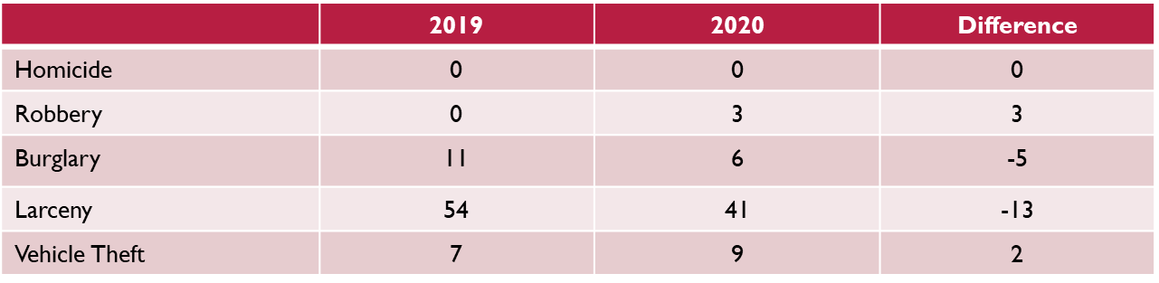

Total May 2019 | Total May 2020 | Number | Difference
95 | 80 | -15 | -16%

 | Jan - Dec  2019 | Jan – Dec  2020 | Difference
Homicide | 0 | 0 | 0
Robbery | 12 | 18 | 6
Burglary | 39 | 28 | -11
Larceny | 262 | 268 | 6
Vehicle Theft | 33 | 39 | 6

Jan - Dec 2019 | Jan – Dec 2020 | Number | Difference
489 | 447 | -42 | -9%

Strategic Response

N/A

Complaints and Action Forms
- Noise Complaint La Pura Vida (Windy Hill)

Meetings
- Attended CID Meeting via Zoom

Zone 2- Major Campisi

Monthly Comparison
 | Jan - June  2019 | Jan - June  2020 | # Difference
Homicide | 0 | 1 | 1
Robbery | 6 | 10 | 4
Burglary | 32 | 22 | - 10
Larceny | 168 | 111 | - 57
Vehicle Theft | 17 | 18 | 1
Total | Of Selected | Part A – Crimes | - 61

 | Jan  2019 | Jan  2020 | # Difference
Homicide | 0 | 0 | 0
Robbery | 1 | 1 | 0
Burglary | 5 | 5 | 0
Larceny | 34 | 31 | - 3
Vehicle Theft | 2 | 1 | -1
Total | Of Selected | Part A – Crimes | -4

YTD Comparison
NIBRS Group A Offenses

 | 2019 | 2020 | Total #  Difference | Percentage Difference
Persons Crimes | 69 | 64 | - 5 | - 7 %
Property Crimes | 349 | 237 | - 112 | - 32%
Society Crimes | 58 | 79 | 11 | 36 %  Note – 74 are Drug Offenses (4 weapon &  1 prostitution)

Strategic Response
- IZP along Roswell Road –
- Sky Watch was at White Water
- Sky Watch currently at Andretti’s
- IZP in the Tom Read Dr Community

Complaints Since Last Meeting
- Traffic Complaint --
Cloverdale Drive – George’s Garage –
Illegally parked vehicles

Meetings
- Tom Read Dr / Seminole Pl Neighborhood

Zone 3- Major Kish

Monthly Comparison (-21%)

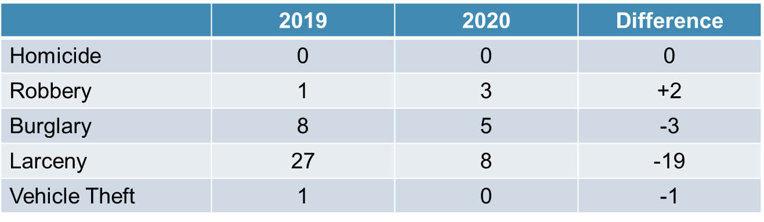

Year-to-Date Comparison (-57%)

 | 2018 | 2019 | Difference
Homicide | 0 | 1 | +1
Robbery | 8 | 14 | +6
Burglary | 36 | 33 | -3
Larceny | 297 | 284 | -13
Vehicle Theft | 26 | 22 | -4

Complaints & Response
- 145 Cole St – Loud exhaust
- 478 Henry Dr - 37
- Parkway Plaza - Homeless
- Rigby St – 38/dumping/discharging guns
- Square – 37 loading zone
- CCT Transfer – 54/64 (Cobb request)
- Fairground St between Roswell & S. Loop– Loud vehicles/racing
- McNeel Alley - Dumpster
- 41 @ Allgood – Loud vehicles/racing
- Texaco S Loop @ Manget – 54
- Grogan Community Center – ZP
- 195 Fowler Circle - 37
- Sessions St. – Parking issue
- 316 Lyman St - ZP

Ongoing Strategies
- Shift and unit patrols through the S. Marietta Pkwy corridor and in the neighborhoods
- Increased patrols at CCT transfer station
- Update CT agreements with businesses along S. Marietta Pkwy
- Traffic Enforcement in complaint areas
- Foot Patrols in Wal-Mart, continued usage of Ghost Car, need increased effort based on last month’s increase
- Communication with CIU regarding 38 complaints

Zone 4- Major Marshall

Monthly Comparison

YTD Comparison

Part 1 Crime Totals

YTD Part 1 Crime Totals

MONTHLY ZONE TOTALS

Strategic Response

Complaints Since Last Meeting

Meetings

Detectives – Lt. Rutland

Monthly Statistics – June 2020

Detectives
- 4 deaths or suicide
- 10 burglaries
- 22 larcenies
- 5 robberies
- 1 missing person
- 4 sex & CAC cases
- 10 MVTs
- 5 terroristic threats
- 19 assaults

Cyber
- Numerous protest/riots threat reports
- 5 LE safety threat reports
- Gang cooperation/BCF intel threat report
- MHS student related social media threats
- Zone 2, district 12 YTD calls for service 2-year comparison

TFOs

- Mileshko – quitter
- Miller – 2 Dag, 0 arrests, & $350K seized, $720K laundered.
- Burgess – Jamaican constables trafficker arrests

Upcoming Events

STEP – Sgt Honea

Details/Events/Training
- MATEN Meeting - CANCELLED
- CRT Training
- Hands Free Detail with GSP
- Juneteenth Detail

STEP Crash Investigations

- No STEP Callouts during the month of June

STEP Crash Investigation Activity
- Search Warrants Obtained 0
- Post Crash Vehicle Exams 0
- FARO Scene Scans 0
- Total Investigative Hours 110

STEP Monthly Activity

- Fatality Crashes 000
- Serious Injury Crashes 000
- Traffic Stops 410
- Citations Issued 517
- Warnings Issued 057
- Arrests 020
- Hit and Run Cases Assigned 012

Hands Free Detail w/ GSP

STEP conducted a Hands-Free driving detail on June 10th with the help of the Georgia State Patrol.
- Total Citations Issued 87
- Hands-Free Violations 39
- Seatbelt Violations 32
- Other Violations 16
Arrest Made 04

Citywide Crash Data

- Total Crashes 281
- MPD Crashes involving DUI 013
- STEP Crashes involving DUI 000
- Fatalities 000
- Serious Injuries 000

Crash Data

- Total Crashes 427
- MPD Crashes involving DUI 006
- STEP Crashes involving DUI 000
- Fatalities 000
- Serious Injuries 001

Top Four Crash Locations

- Cobb Parkway @ Canton Road
1 Failure to Yield
4 Following Too Close
- N. Marietta Pkwy @ Cobb Parkway
3 Following Too Close
1 Failure to Yield
- Church Street @ Sessions Street
2 Following Too Close
6 Other
- Franklin Gateway @ Delk Road
3 Following Too Close
1 Improper Lane Change

Square Parking Enforcement Activity

- April 000
- May 063
- June 103

CRU- LT Baldwin

Monthly Events
- SRO’s assigned to MW on a rotational basis
- Assisted with several, peaceful protests/demonstrations
- All events were cancelled due to the COVID 19 Pandemic
- Assisted School System with various school details.
- Continue maintaining Fogger Disinfectant
- Providing disinfecting of requested areas and vehicles.
- Senior Citizen Detail every Thursday
- Assisted with STEP Hands Free Detail.
- Participated in Community Relations Meeting with DA’s Office

SRO
MARIETTA HIGH
- Assist school system with patrolling closed schools and recreational areas.
- Assigned to MW on rotational basis
MARIETTA MIDDLE
- Assist school system with patrolling closed schools and recreational areas.
- Assigned to MW on rotational basis
ELEMENTARY
- Assist school system with patrolling closed schools and recreational areas.
- Assigned to MW on rotational basis

EXPLORERS

- Explorer training and activities have been postponed indefinitely due to pandemic.
- Should return by start of school year

VOLUNTEERS

- All volunteer activities have been postponed indefinitely due to pandemic and extension of Governor’s order

Graffiti Incidents
- Numerous graffiti incidents this month around the city, especially at Brown Park. All were documented and removed.

Criminal Trespass

  - Cleared two camps. One on Walmart property (1785) and the second behind 200 N. Fairground Street.
  - Started to enter select camps due to problems in community.

Crime Interdiction Unit – Sergeant Liedke

Felony Arrests
Misdemeanor Arrests

Complaints Cleared

Zone 1

Zone 2

Zone 3

Zone 4

Shift Assistance & Details

Canine Unit

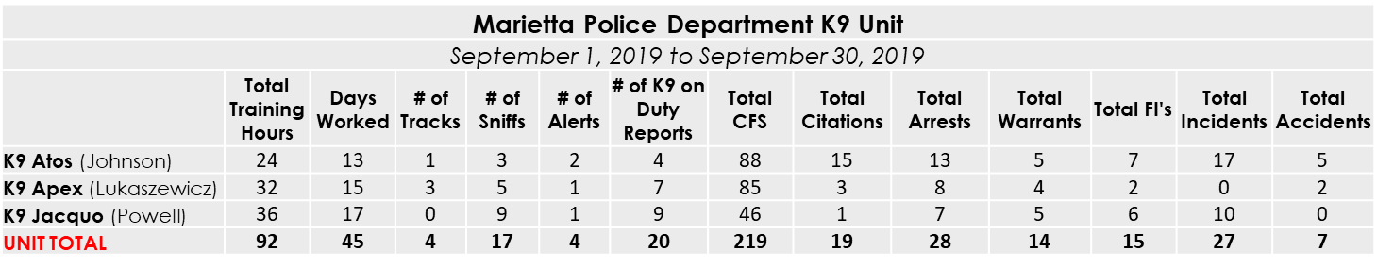

Additional Information: ATOS

- 9/5 - Tracked a s44 suspect on Washington Ave
- 9/7 - Assisted DEA with a whisper stop resulting in the seizure of 2.2 pounds of meth and $3000
- 9/13 - Deployed K9 Atos for a vehicle sniff resulting in the seizure of multiple bags of methamphetamine, marijuana, and a firearm
- 9/18 - Training with SWAT
- 9/23-9/25 - GPSTC Search Warrants and Affidavits Class
- 9/30 - s54 stop led to seizure of 2 grams of methamphetamine
- 9/30 - Deployed K9 Atos for a vehicle sniff, located multiple bags of marijuana residue and multiple marijuana cigarettes

Additional Information: APEX
- 9/14 - Located 52.8g Marijuana on a traffic stop. 1 charged with Felony Possession
- 9/14 - Assisted Bartow/Acworth/Cobb in a track for a 10-80/45 suspect
- 9/16 - about an ounce of weed and MDMA on a traffic stop assist.
- 9/22 - K9 was requested and deployed to search a room where an armed robbery (x4) and carjacking suspect was believed to be held up. Once outside the door, the suspect surrendered. K9 Apex was then deployed to search additional rooms on the 2nd floor for the other suspect. We searched every room with K9 Apex. The 2nd suspect was eventually located on the third floor.
- 9/28 K9 Apex completed a building search on a sig7 for a business/warehouse. No suspects were located.
- 9/29 54 vehicle stop lead to the seizure of about 1.5g Heroin. 1 charged with VGCSA Possession and Wanted person located.

Additional Information: JACQUO
- K9 Training: 09/04, 09/11, 09/18(SWAT/K9), 09/25
- 09/04: Assisted shift with s50 on Wilson Cir.
- 09/06: Assisted Atlanta P.D. with arrest of a serial rapist from Fulton County at Tip Top (confirmed on at least 8 attacks)
- 09/10: CIU attended Z3 Town Hall Meeting
- 09/11: K9 Training, Smyrna K9 attended and assisted with getting him ready for Cert.
- 09/15: Worked for Morning Watch
- 09/15: K9 Sniff for Officer Salyers led to 3 crack rocks (0.4 grams total) and 0.1 grams of Marijuana. 1 Arrest!
- 09/19: covered 4 hrs of ewatch for Washington
- 09/24: Sgt. Liedke and I caught 2 s44 suspects within 1 minute of committing the crime at Motel 6!
- 09/26: Requested by Agent Burgess for a sniff of a plane at Hartsfield.
- 09/27: Traffic stop led to discovery of 4.4 ounces of Marijuana.
- 9/27: Recovered stolen gun on s83

Shift Assistance & Details
- SWAT Suppression Detail

CIU Complaints

Zone 1
- Barber shop on 41

Zone 2
- 1111 Beech Street
- 500 Williams Drive 613

Zone 3
- SiSi

Zone 4
- 211 Kimberly (Camera)
- 84 Griggs
- 1189 Longwood
- 1650 Massachusetts
- 41 Reynolds Street

Side Note
CIU has made:
130 arrests
127 days
031 Search Warrants
00 Complaints
00 MPD100’s

End of Discussion
Nothing Further
End of Meeting 10:16 a.m.

